**SERVO DRIVELINE TRANSMISSION AND FAULT MATHEMATICAL MODEL**

**By S.Ozkucuk**

**Basic Mechanical Relations for Gear System**

$$\sum{T}=Jα →\left(\sum{F}=Ma\right) Newton^{'}s law$$

$$T:torque$$

$$α:angular acceleration$$

$J:the mass moment of inertia$,

(Inertia defines the resistance of an object to change in its angular velocity about an axis of rotation. Inertia opposes change in motion.)

**Gear Box ratio: $N_{GB}=\frac{motor speed}{load speed}=\frac{w_{m}}{w_{l}}=\frac{r_{l} (or n_{l})}{r_{m} (or n_{m})} , n:number of teeth$**

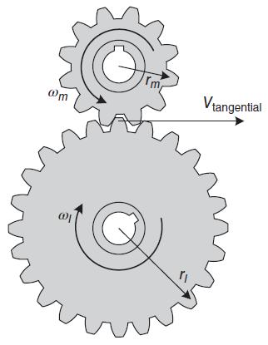

**Fig.1:** Gear Mesh System

The tangential speed equation: $V_{tangential}=w_{m}r_{m}=w_{l}r_{l}$

Power related equation: $P_{m}=T_{m}w_{m} , P_{l}=T_{l}w_{l} →efficiency: \frac{P_{l}}{P_{m}}×100$

$${where, T}_{m}:torque on the motor gear$$

$T_{l}:torque on the load gear$

If we assume the efficiency of the system 100% : $N_{GB}=\frac{w_{m}}{w_{l}}=\frac{r_{l}}{r_{m}}=\frac{n_{l}}{n_{m}}=\frac{T_{l}}{T_{m}}$

**Reflected Inertia**

The reflected inertia is seen by the motor, changes when the load is coupled to the motor through a **direct coupling** or **gear box**.

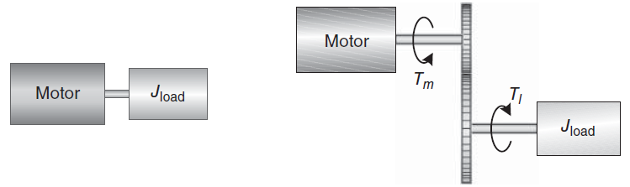

(a) Direct drive (b) Gear box drive

**Fig. 2:** Reflected inertia and torque for (a) Direct drive system, (b) Gear box drive system

Direct drive: $T_{m}=J_{load}{\ddot{θ}}_{m}$

Gear box drive: $T_{l}=J_{load}{\ddot{θ}}_{l} → \left(N_{GB}T_{m}=J_{load}{\ddot{θ}}_{l}\right)$

$$Where, {\ddot{θ}}_{l (or m)}:angular acceleration of the load shaft (or motor shaft)$$

$T_{l}:motor torque transferred to the load through the gears$

For a gear box drive system, when the gears rotate, the distance traveled along the circumference of each gear is the same and given by:

$$r_{l}θ_{l}=r_{m}θ_{m}$$

If we differentiate both sides twice:

$$r_{l}{\ddot{θ}}_{l}=r_{m}{\ddot{θ}}_{m}$$

Solving the equation for ${\ddot{θ}}_{l}$ and substituting into $N_{GB}T_{m}=J_{load}{\ddot{θ}}_{l}$ gives:

$$\frac{r_{l}}{r_{m}}T_{m}=J_{load}\frac{r_{m}}{r_{l}}{\ddot{θ}}_{m} → T_{m}=J_{load}{\left(\frac{r_{m}}{r_{l}}\right)}^{2}{\ddot{θ}}_{m}= J_{load}\frac{1}{N_{GB}^{2}}{\ddot{θ}}_{m} , similarly \left[\sum{T}=Jα\right]$$

Load inertia reflected to the motor through the gears:

$${T_{m}=J_{load}\frac{1}{N_{GB}^{2}}{\ddot{θ}}_{m}=J}_{ref}{\ddot{θ}}_{m} → J_{ref}=\frac{J_{load}}{N_{GB}^{2}}→ J_{ref}=\frac{1}{η} \frac{J_{load}}{N_{GB}^{2}}$$

**Total Inertia:**

$J_{total}=J_{m}+J_{on motor shaft}+J_{ref}$

Where, $J_{on motor shaft} isthe total external inertia on the motor shaft$

$J_{ref} is the total inertia reflected to the motor shaft$

$J_{m} is motor inertia$

**Reflected Torque**

Power related equation: $P_{m}=T_{m}w_{m} , P_{l}=T_{l}w_{l}→efficiency \left(η\right): \frac{P_{l}}{P_{m}}×100$

We can write:

$$T_{m}=\frac{1}{η}\frac{w_{l}}{w_{m}}T_{l}=\frac{1}{η}\frac{T_{l}}{N_{GB}}$$

**Fault on the Tooth of the Gear System**

Assumption for Broken tooth model:

Broken tooth don’t stop the motion. Free moment of inertia continues the motion (there is no locking or complete disconnection)

Speed increases, torque decreases

